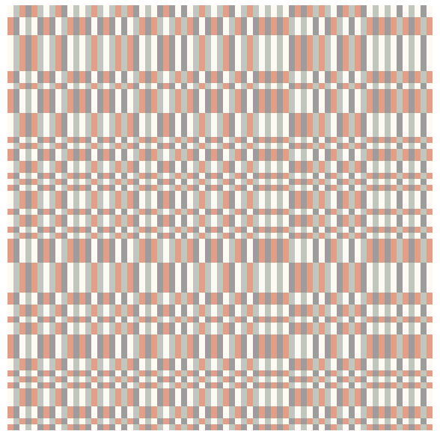

sqrt5_2748x4722z80_80

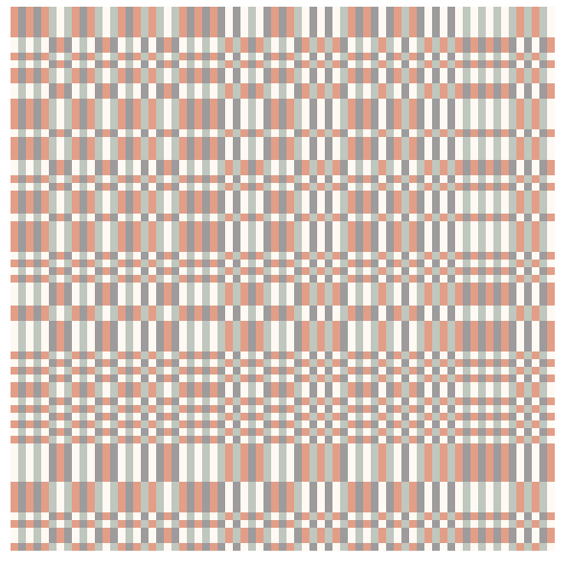

sqrt2_6695_11081z80_80

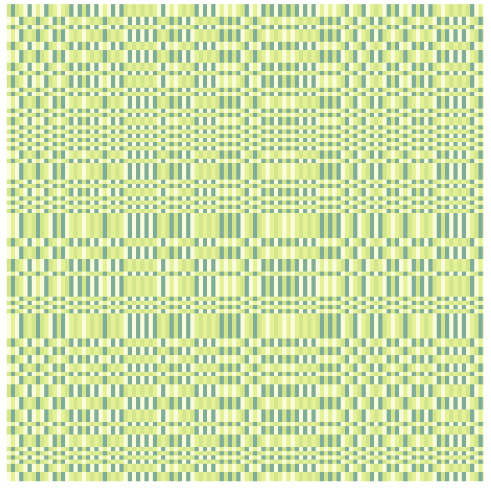

sqrt3_0x0z_120_120

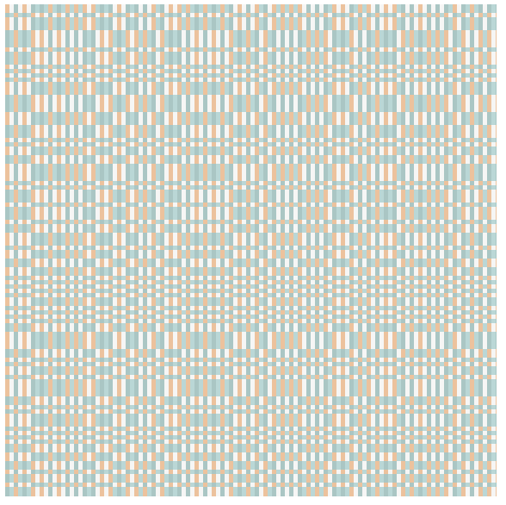

sqrt2z0_0x120x120

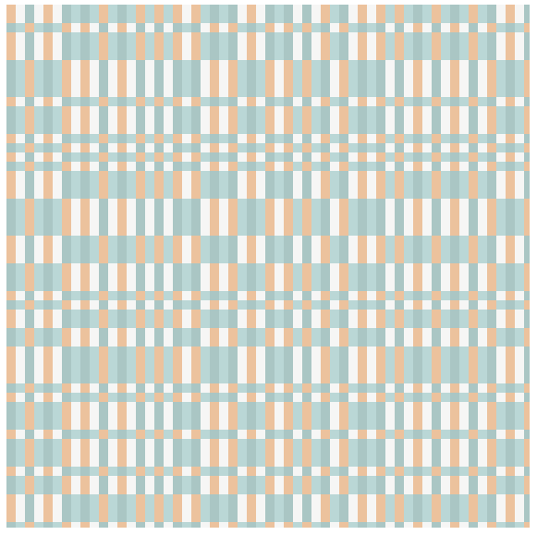

sqrt2z0_0x75_75

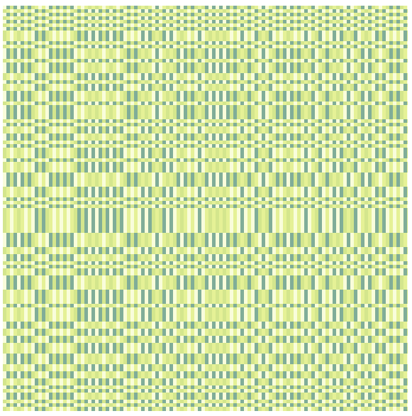

sqrt5z7353_9985x120_120

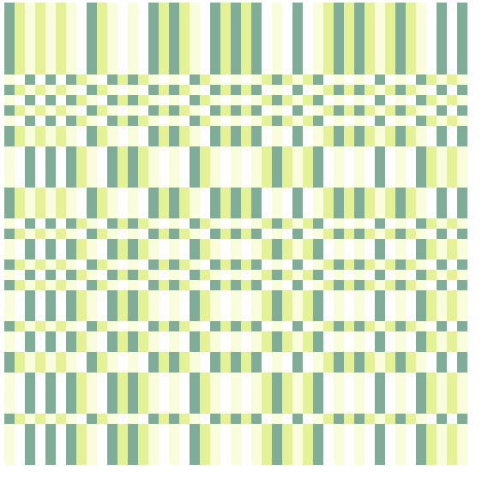

sqrt5z10862_14152x45_45

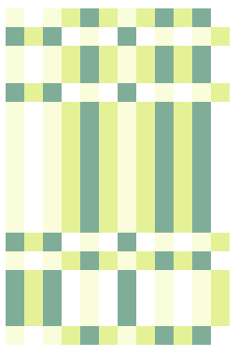

sqrt5z10862_14152z12_18

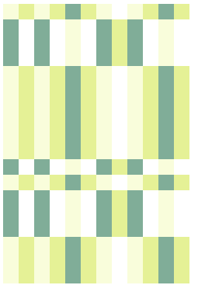

sqrt5z12836_6695x12_18

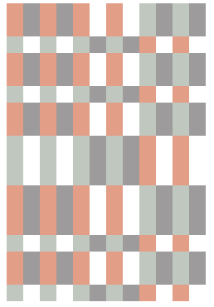

sqrt2z12617_6257x12_18s

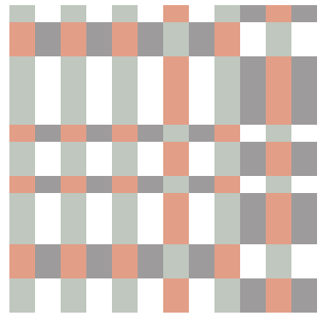

sqrt7x15906_13932x12_18-30w_20h